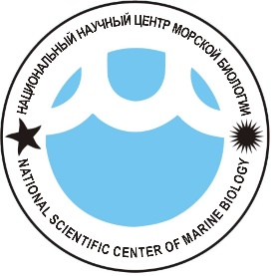

Школа молодых ученых – 2017

***«Простые и точные методы молекулярной диагностики вредоносных цветений водорослей»,***

в рамках конференции

***Научно-технологические разработки в области изучения и мониторинга морских биологических ресурсов***

Владивосток, Россия, 24 мая 2017 г. с 13:00 до 17:00

**Место проведения – Приморский океанариум**

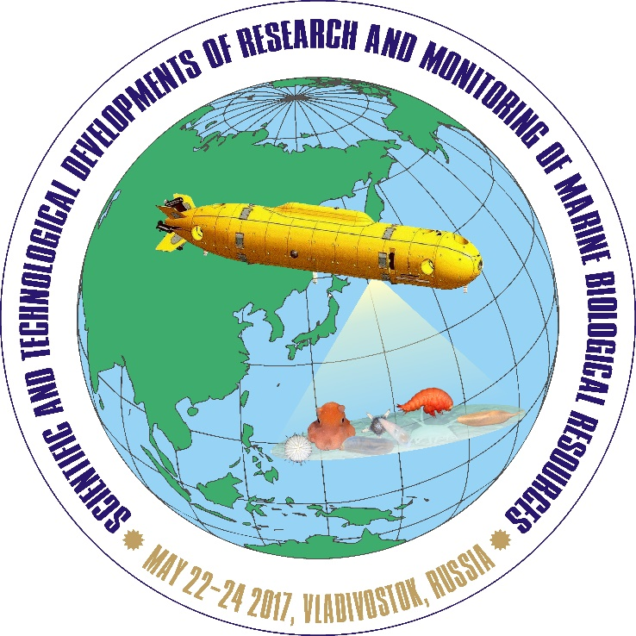

**Анонс мероприятия**

В рамках школы молодых ученых будут проведены лекции и практические занятия на тему молекулярных методов обнаружения токсичных видов микроводорослей с помощью ДНК-хромотографического чипа.

Школу будет проводить ведущий мировой специалист в данной области Доктор Сатоши Нагаи (Prof. Satoshi Nagai), возглавляющий Группу геномики окружающей среды в Национальном научно-исследовательском институте рыбного хозяйства (Иокогама, Япония). В настоящее время он занимается внедрением метагеномного подхода в рутинный мониторинг состава морских микроогранизмов.

Также в составе исследовательских групп С. Нагаи стал известен следующими разработками: молекулярное обнаружение бактерий при пищевых отравлениях, ДНК-ДНК гибридизация для морских бактерий, молекулярное обнаружение и количественное определение токсичных динофлагеллят, еиспользования высокополиморфных генетических маркеров и анализ генетических структур для токсических динофлагеллят.

**Сбор студентов и молодых ученых, желающих принять участие в работе школы состоится 24 мая 2017 г. в 12:30, ДВФУ, корпус В.**

**Доставка участников в Приморский океанариум будет осуществлена автобусом ДВФУ (табличка «Школа молодых ученых – 2017»).**

**Рабочий язык школы английский.**

**Dr. Satoshi Nagai**

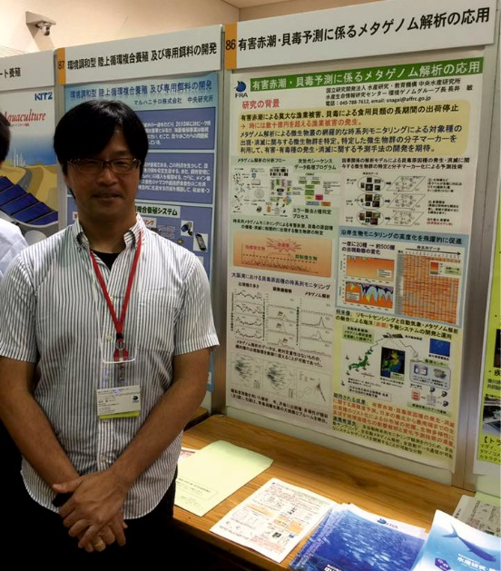Dr. Satoshi Nagai is working for Japan Fisheries Research and Education Agency, National Reserch Institute of Fisheries Science, Research Center for Bioinformatics and Biosciences as a group lead at the Environmental genomics group. Recently, he has focused on metagenomic approach to introduce this technology to routine monitoring. He has participated a lot of metagenome projects to study not only the biodiversity of marine eukaryote and bacteria, but also feeding habits of sardines, eels, and abalones. He also has collaborated about this with many research institutes oversea, such as Finland, Bulgaria, Singapore, Chile, Australia and Russia.

**Method and technology development**:

* Developed/refined sampling and analysis methods for the molecular detection of food poisoning bacteria (NRIFS, Japan);
* Developed/refined DNA-DNA hybridization methods for marine bacteria (NRIFS, Japan);
* Developed methods for the molecular detection and quantification of toxic dinoflagellates (FEIS, Japan).
* Developed methods for the highly polymorphic genetic markers and analysis of genetic structures for toxic dinoflagellates (Tokyo Univ., TNFRI and FEIS, Japan).

**Patents**

* News probes and microarray system for detecting of harmful algal bloom causing species. PATPEND: Mar. 2010-48242. Inventors: Togawa N, Nagai S, Yamaguchi M, Sakamoto S.
* 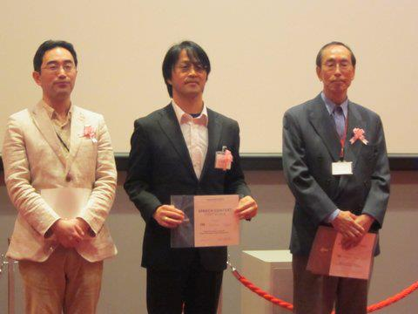A new method for manufacturing the diarrheic shellfish poisoning okadaic acids, dinophysistoxins and the fat-soluble toxin pectenotoxins. PATPEND: Jun. 2009-141174. Inventors: Suzuki T, Nagai S, Kamiyama T.
* A new technique for detection of gene mutation in the manila clam. PATPEND: Mar. 2009-081687. Inventors: Hamaguchi M, Nagai S, Sasaki M.
* Novel virus infectious to *Teleaulax amphioxeia* Cryptophyceae and the use. PATPEND: Feb. 2008-037662. Inventors: Nagasaki K, Tomaru Y, Takao Y, Nagai S, Tanabe H.

**Academic and Community Service**: Manuscript reviewer for *Aquatic Microbial Ecology*, *Biochemical Systematics and Ecology*, *BMC Genomics*, *Chinese Journal of Oceanography and Limnology*, *European Journal of Protistology, Fisheries Science*, *Limnology & Oceanography*, *Molecular Ecology*, *Phycologia, Plankton Biology & Ecology, Journal of Phycology*, *PLoSONE*, Proposal reviewer for NSF Biological Oceanography, Pre-proposal reviewer for MIT grant,

Associate editor for *Plankton & Benthos Research*, Associate editor for *BMC genomics*.

**Main PUBLICATIONS (last 5 years)**

* **Nagai S**, Miyamoto S, Ino K, Tajimi S, Nishi H, Tomono J. Easy detection of multiple *Alexandrium* species using DNA chromatography chip. **Harmful Algae** 51: 97-106 (2016).
* **Nagai S**, Hida K, Urushizaki S, Onitsuka G, Yasuike M, Nakamura U, Fujiwara A,Tajimi S, Kimoto K, Kobayashi T, Gojobori T, Ototake M. Influences of diurnal sampling bias on fixed-point monitoring of plankton biodiversity determined using a massively parallel sequencing-based technique. **Gene** 576: 667–675 (2016).
* **Nagai S**, Hida K, Urusizaki S, Takano Y, Hongo Y, Kameda T, Abe K. Massively parallel sequencing-based survey of eukaryotic community structures in Hiroshima Bay and Ishigaki Island. **Gene** 576: 681–689 (2016).
* Basti L, **Nagai S**, Watanabe S, Tanaka Y. Neuroenzymatic activity and physiological energetics in Manila clam, Ruditapes philippinarum, during short-term sublethal exposure to harmful alga, Heterocapsa circularisquama. **Aquatic Toxicology** 176: 76-87 (2016).
* Basti L, Uchida H, Matsushima R, Watanabe R, Suzuki T, Yamatogi T, **Nagai S**. Influence of temperature on growth and production of pectenotoxin-2 by a monoclonal culture of Dinophysis caudata. **Marine Drug** 13: 7124-7137 (2015).
* Matsushima R, Uchida H, **Nagai S,** Watanabe R, Kamio M, Nagai H, Kaneniwa M, Suzuki T. Assimilation, accumulation, and metabolism of Dinophysistoxins (DTXs) and pectenotoxins (PTXs) in the several tissues of Japanese scallop Patinopecten yessoensis. **Toxins**, 7: 5141-5154 (2015)
* **Nagai S**, Yasuike M, Nakamura Y, Tahvanainen P, Kremp A. Development of ten microsatellite markers for Alexandrium ostenfeldii, a bloom-forming dinoflagellate producing diverse phycotoxins. **J. Applied Phycology** (2014).
* Kamiyama T, Yamauchi H, **Nagai S**, Yamaguchi M. Differences in abundance and distribution of Alexandrium cysts in Sendai Bay, northern Japan, before and after the tsunami caused by the Great East Japan Earthquake. **Journal of Oceanography** 70: 185-195 (2014).
* Nishikawa T, Hori Y, **Nagai S**, Miyahara K, Nakamura Y, Harada K, Tada K, Imai I. Long-term (36-year) observations on the dynamics of the fish-killing raphidophyte Chattonella in Harima-Nada, eastern Seto Inland, Sea. **Journal of Oceanography** 70: 153-164 (2014).
* Natsuike M, **Nagai S**, Matsuno K, Saito R, Tsukazaki C, Yamaguchi A, Imai I. Abundance and distribution of toxic Alexandrium tamarense resting cysts In the sediments of the Chukchi Sea and the eastern Bering Sea. **Harmful Algae** 27: 52-59 (2013).
* Tahvanainen P, Alpermann TJ,Figueroa RI, John U, Hakane P, **Nagai S**, Blomster J, Kremp A. Patterns of post-glacial genetic differentiation in marginal populations of a marine microalgae. **PLOS ONE** 7 (12) e53602 (2012).
* **Nagai S**, Yamamoto K, Hata N, Itakura S. Study of DNA extraction methods for use in loop-mediated isothermal amplification detection of single resting cysts in the toxic dinoflagellates Alexandrium tamarense and A. catenella. **Marine Genomics 7:** 51-56 (2012).
* **Nagai S**, S Itakura. Sensitive and specific detection of the toxic dinoflagellates Alexandrium tamarense and Alexandrium catenella from single vegetative cells by a loop-mediated isothermal amplification method. **Marine Genomics** 7: 43-49 (2012).
* **Nagai S**, Suzuki T, Nishikawa T, Kamiyama T. Differences in the production and excretion kinetics of okadaic acid, dinophysistoxin-1, and pectenotoxin-2 between cultures of Dinophysis acuminata and D. fortii isolated from western Japan. **Journal of Phycology** 47: 1326-1337 (2011).
* **Nagai S**, Development of a multiplex PCR assay for simultaneous detection of 6 Alexandrium species (Dinophyceae). J**ournal of Phycology** 47: 703-708 (2011).
* Kamiyama T, **Nagai S**, Suzuki T, Miyamura K. Effect of temperature on production of okadaic acid, dinophysistoxin-1, and pectenotoxin-2 by Dinophysis acuminata in culture experiments. **Aquatic Microbial Ecology** 60: 193-202. (2010).
* Nishitani G, **Nagai S**, Baba K, Kiyokawa S, Kosaka Y, Miyamura K, Nishikawa N, Sakurada K, Shinada A, Kamiyama T. High congruence of Myrionecta rubra prey and Dinophysis spp. plastid identities as revealed by genetic analyses on isolates from Japanese coastal waters. **Applied and Environmental Microbiology** 76: 2791-2798. (2010)
* Nishikawa T, Hori Y, **Nagai S**, Miyahara K, Nakamura Y, Harada K, Tanda M, Manabe T, Tada K Long-term Phytoplankton Dynamics in Harima-Nada, Eastern Seto Inland Sea, Japan During a 35 year period from 1973 to 2007. **Estuaries and Coast** 33: 417-427. (2010).

**AWARDS**

* + Nishitani G, **Nagai S**, Yamaguchi S, Kamiyama T (2009). Successful cultivation of the toxic dinoflagellate *Dinophysis caudata* (Dinophyceae). Plankton & Benthos Research, 3: 78-85. Best article award at Plankton Biology & Ecology in the fiscal 2008.
  + An excellent research prize in Japanese Society of DNA Polymorphism Research in 2006: Award winner, **S. Nagai**, G. Nishitani, S. Yamaguchi et al.: Title, Microsatellite markers reveal population genetic structure in the noxious red tide-causing algae *Heterosigma akashiwo* (Raphidophyceae) in Japanese coastal waters.
  + An excellent research prize in Japanese Society of DNA Polymorphism Research in 2006: Award winner; N. Yasuda, **S. Nagai**, M. Hamaguchi, and Kazuo Nadaoka; Title, Genetic structure of the crown-of-thorns starfish, *Acanthaster planci* (L.), throughout the Ryukyu islands and southern part of the main lands of Japan.
  + An excellent research prize in Japanese Society of DNA Polymorphism Research in 2004: Award winner, **S. Nagai**, CL Lian, M. Suzuki, M. Hamaguchi et al. Title, Microsatellite markers reveal population genetic structure of the toxic dinoflagellate *Alexandrium tamarense* (Dinophyceae) in Japanese coastal waters.